GRIFFITH SAFETY BOARD

May 3, 2018

The Griffith Safety Board was called to order by Liz Goral at 6:30

Those in Attendance

Liz Goral Griffith Safety Board Member
Debbie Dillon Griffith Safety Board Vice-Chairman
RoAnn Purgert Griffith Safety Board Secretary
Stan Dobosz Griffith Safety Board Member
Shawn Graham Griffith Safety Board Member

The meeting opened with the pledge of allegiance. The following items were discussed:

Approval of April 5, 2018 minutes: Motion by Safety Board member Dobosz
Seconded by Safety Board member Dillon
Motion Carried 4-0

Reports: Griffith Police Department

Chief Mance read the monthly report for March.

Reported crime in March 2018 fell by 5% compared to March 2017 and fell 46% from the average number of crimes reported during the past five months of March.

Griffith Fire Department

Chief Schoon read the March monthly report.

162 incidents which reflects an 11% increase over February 2018 and 13% increase over March 2017. There was a total of 167 volunteer hours for the month of March.

There will be a Boot Drive from 9:00 to 1:00 on Saturday May 5th, weather permitting, with proceeds to benefit Hoosier Burn Camp.

VEST

Nothing

FOP Post 161

Nothing

New Business

Swearing in of Officer Merkel GR78

Recommendation to the Town Council the purchase of two new police cars

Motion Safety Board member Dillon
2nd Safety Board member Dobosz
Motion carried 5-0

Addition to the Agenda

Recommendation to the Town Council to purchase two vehicles for the Griffith Fire Department pending available funds.

Motion Safety Board member Purgert
2nd Safety Board member Dillon
Motion carried 5-0

Approval of Griffith Police Department General Order 3A Promotions – tabled to the June meeting.

Announcements

Nothing

No Questions/comments from the floor.

Meeting closed at 6:40
/lm
Liz Goral – 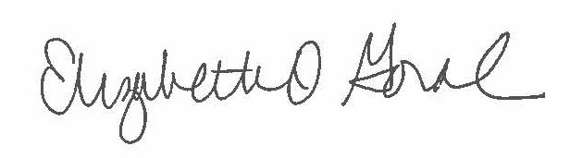
RoAnn Purgert 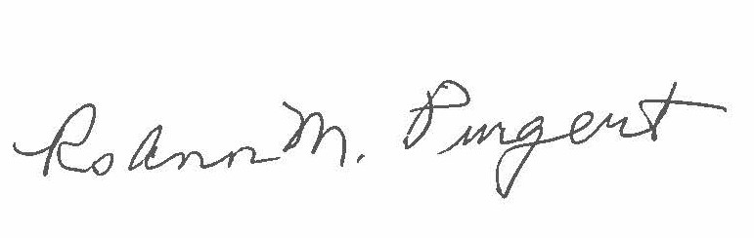
Debbie Dillon 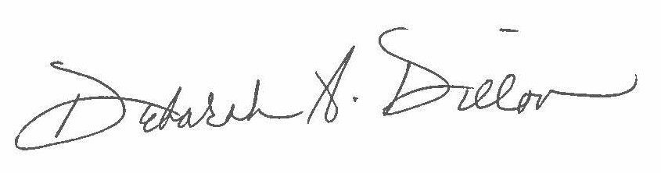
Stan Dobosz 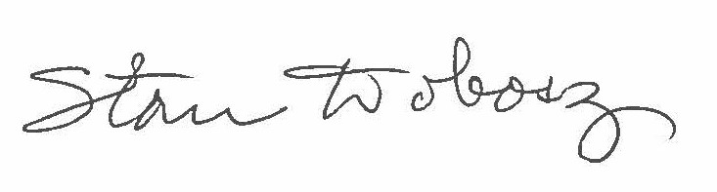

Shawn Graham 